SIERRA LAKES AMPHIBIAN SURVEY PROTOCOL

BACKGROUND

Amphibian surveys occur in a subset of lakes first surveyed in 1995-2001. In the selected areas, all lakes containing mountain yellow-legged frogs will be resurveyed. All resurvey lakes are listed in the “Resurvey Lakes” list, along with lake name, drainage, topo name, water type, UTM coordinates, and priority for survey. All resurvey data will be collected on small handheld computers (Palm Treo) and data will be uploaded directly into the lakes database upon your return to SNARL. The Treo units are quite durable, but can be destroyed by moisture. Therefore, during data collection units will be enclosed in a waterproof soft case through which you can see the screen and enter data. In addition, when not collecting data, the Treo units will be stored in waterproof plastic Otter Boxes that will protect the units while in your backpack and also hold extra batteries and a backup module. The Handspring units should generally be in one or the other waterproof case. Remember that if the Treo gets wet, all of the data you collected will be lost. To ensure that the Treo units stay free of moisture, make sure the water proof cases are dry. If you see any condensation on the Treo units, make sure to thoroughly dry out the cases. At the end of each day of data collection, attach the backup module to the Treo unit and back up all of the data. ALWAYS leave the backup module at camp (e.g., in the Otter Box) when out surveying to ensure that a copy of the data would survive even if the Treo unit was lost or destroyed during surveying.
When returning from the field with a Treo unit full of data, upload the data into the database by placing the unit in the ActiveSync cradle and pushing the cradle hotsync button. The status of the download is displayed on the desktop computer and on Treo unit. When the download is complete, be sure to check the message log on the desktop computer for errors. Also check the Treo for any data that was not transferred to the database. For example, duplicate SiteIDs cannot be downloaded into the database. If one crew member downloaded data for Site 10343 and you try to download data for the same SiteID and date (because you either surveyed the same lake by mistake or you or the other crew member wrote down the wrong SiteID), your data for this site will remain on your Treo. Try to resolve any problems with Tom (or Roland) before going back out into the field. If you are unable to do so, leave a note for Tom and he will try to resolve the problem in your absence.
At each resurvey site, begin your data collection by entering all site and survey description information. Then conduct the amphibian/reptile/fish survey by walking the perimeter of the lake or pond (but zigzag through meadows and marshes) and the first 100 m of each inlet and outlet stream, recording data on the abundance of each amphibian/reptile species and lifestage seen in your notebook. Immediately upon finishing the survey, enter the amphibian/reptile information into the Treo unit. You may be instructed to conduct moutIf you found mountain yellow-legged frog tadpoles during the survey, conduct mouthpart inspections on 10-20 tadpoles. Finally, collect skin swabs at selected sites. Enter all data into the Handspring. Before moving on to the next resurvey site, go through all of the data you entered, making sure that all fields have been filled out and that all values are correct. Most fields are “required” fields, meaning that you cannot exit the record (data for each lake is called a record) until data have been entered into those fields. In addition, many fields have error checking associated with them that will not allow data to be entered if the values fall outside of a predefined range. Nonetheless, check all of your data before moving on.
It may be necessary to collect the occasional animal (e.g., for gut content analysis, animals with deformities, dead animals). To collect tadpoles or adults/subadults, euthanize each animal by immersion in anaesthetic (1 microcentrifugre tube of MS-222, 1 microcentrifuge tube of “buffer” per 60 ml of water). Several minutes after the animal stops moving, place it into a sample bottle (30-60 ml for tadpoles, 60 ml for subadults, 60-250 ml for adults), and fill the bottle with ethanol. Label the sample bottle externally with labeling tape wrapped all the way around the bottle. The sample label must contain the Site ID, date, drainage name, species name, and the animal ID (assigned when you entered data into the Handspring). This same information should be written on an internal label. It is critically important that only one animal be placed into a single bottle and that the bottles be filled to the brim with ethanol. Also, remember that amphibians are ~80% water and the final solution of ethanol should be 70% to ensure proper preservation (stock solution is 95%). Dead animals should also be collected and can be very useful in diagnosing the cause of death. However, only freshly-dead animals can be used for this purpose. Collect dead animals that have died within the last 24 hours or so, identifiable based on the fact that their skin is still largely intact.

Disinfection Protocol
To avoid moving diseases from site to site, you must disinfect your dip nets and other field gear that was in contact with the water and (especially) with diseased animals before moving on to the next site. The only exception to this rule is when your next survey site is either directly connected or is within 100 m downstream of the site you just surveyed and is connected to it by a stream. To disinfect your gear, use a 0.1% solution of Quat 128. Fill a dry bag with 2 or 3 liters of water and add 30 or 45drops of Quat 128 using a dropper. Soak all items for 5 minutes. After disinfecting your gear, wash it off with water at the next survey site. Because it is generally not practical to disinfect boots, clothing, and your legs (assuming that your legs were in contact with the water), be sure to dry these completely before moving to another survey site. Because Quat 128 will retain its effectiveness for 24 hours, the most efficient disinfection method is to mix up your disinfection solution in the morning at your first survey site and use this solution for all disinfections for the remainder of the day. At the end of the day, dispose of the disinfection solution >100 m from water. Quat 128 breaks down when it comes it to contact with organic material. Therefore, the best disposal sites are those containing disturbed organic soil (e.g., trail tread in a forested area).

DATA COLLECTION

General Site Description

Site ID: This is a critical number, as it will be used to link the data to a particular body of water and to identify all samples. This ID is written on the 7.5' maps available for crews to take into the field. Check the Site ID carefully before tapping on the SiteID field and selecting the SiteID from the list. Once you have selected a SiteID, you will see that other site information including lake name, water body type, drainage, elevation, topo name, county jurisdiction, wilderness, site location description, and UTM coordinates will automatically be entered into the appropriate field.

Date: Tap on the Survey Date field and select the correct date.

Map code for site: This is the water body type as depicted on the 7.5’ topographic map. This field will be automatically filled in with data obtained during the intial survey. The categories are perennial, ephemeral, marsh, meadow, unmapped marsh, unmapped pond. Perennial lakes and ponds are shown in dark blue, ephemeral lakes and ponds are depicted with blue stipple, and marshes are indicated by a marsh symbol. Meadows are shown in white and are often named on the map (e.g., Dana Meadow). Check the entry against the map to ensure it is correct. Record any discrepancies under the field named “Other site discrepancies” (see below).

Other site descriptors: Check the lake name, drainage, elevation, topo name, county, jurisdiction, and wilderness against the map to ensure the results of the initial survey are correct. For all these fields, record any discrepancies only under the field named “Other site discrepancies”. Elevation is always given in meters so if your topo map is in feet, use the calculator on the Handspring unit to convert the map elevation to meters. Only record a new site elevation if the elevation on the Handspring unit is off by >20 m. Remember that if the exact site elevation is not given on the topo map, site elevation is estimated by averaging the elevation of the first contour line below the site and the first contour line above the site.

Site location: Check the site location information against the map to ensure that they are accurate. If the site location is missing, inadequate, or inaccurate, provide a new one in the Revised site location field. Do not provide any other information in this field. At a minimum, the site location needs to provide the distance and compass direction from the site to two nearby prominent named geographical features (e.g., lakes, peaks, etc.). Lake and peak names, distances, and compass directions should be taken from 7.5' quads.

UTM coordinates: To ensure that the site being surveyed is in fact the same site that was visited previously, compare the UTM coordinates on the Handspring with those determined using your GPS unit. The UTM coordinates on the Handspring were obtained from the center of each water body using a Geographic Information System and should be highly accurate. If your GPS-derived UTM coordinates don’t match those on the Handspring (after correcting for the difference in where the coordinates were measured), record your GPS-derived UTM coordinates under the fields Revised East UTM and Revised North UTM. Do not record any information except UTM coordinates in these fields.

Other site discrepancies: Record discrepancies between the Handspring data and map with regard to lake name, site map code, drainage, elevation, topo name, county, jurisdiction, and wilderness. If you find major discrepancies between the Handspring and map data but are sure that you are at the correct site (based on the SiteID), go ahead and conduct a complete survey of the site. Indicate the fact that discrepancies exist under Site comments.

Survey type: This field has two options: “initial” or “repeat”. All of the data you collect will be from “repeat” surveys, so this field defaults to “repeat”.

Site comments: Describe noteworthy features about the conditions at a site that might affect the quality of your survey or about why a site was not surveyed. For example, if the site is 20% snow covered the water temperature is likely to be very cold and could influence the number of amphibians seen. In contrast, if your survey is conducted on a perfect day (warm, sunny, calm), your survey results will likely be highly reliable. Also include other comments of interest (e.g., “Fairy shrimp seen during survey”).

Suitability for survey: Select “suitable” if the site is surveyable, and if not, select the reason why (dry, frozen, does not exist, stream widening). If the site is not suitable for survey, your selection of “dry”, “frozen”, “does not exist”, or “stream widening” will terminate the data collection process for this site. If you select “suitable”, you will continue to enter data related to the survey description.

Delete site data: If you make a major data entry error, the easiest way to correct the problem is generally to delete the data for that particular site and date and start over. To delete these data, click on the Delete button.

Amphibian/Reptile/Fish Survey Description

To conduct a survey, walk slowly around the perimeter of the site, the first 100 m of each inlet and outlet stream, and any fringing habitats (pools or marshes within 10 m of the feature being surveyed that lack their own site id), counting the number of adults, subadults, tadpoles, and egg masses you find of each amphibian and reptile species. It is easiest to record these data in your notebook and following completion of the survey, enter these data into the Handspring. Use a net to catch amphibians and reptiles for identification whenever necessary. Consult the field guide provided for adult and larval identification. Subadult frogs/toads are those animals that have completely reabsorbed their tails and are fully terrestrial. Toad and treefrog subadults are generally about the size of your thumbnail. Mountain yellow-legged frog subadults are <2.5 cm (1”) long (when measured from snout to vent). For snakes, all individuals <20 cm (8”) long should be recorded as subadults. While conducting the survey, also look for fish. A map of the site need not be drawn unless you find something particularly noteworthy that cannot be described verbally. If a map is necessary, draw it in your notebook, making sure to record the SiteID and date.

Air and water temperature and time measured: Air and water temperature should be measured either at the beginning or end of your site survey. Measure the air temperature from the lake shore at 1 m above the lake surface. Measure water temperature approximately 0.5 m out from shore and 10 cm under the water surface. For both measurements (taken in Celsius), record the time the temperature was measured. Time should always be recorded as 24 hour time (e.g. 4:00 PM = 1600).

Weather observations: Select the appropriate descriptors to indicate the wind conditions (calm, breezy, or windy) and the sky conditions (clear, 5-50% overcast, >50% overcast, or precipitating).

Amphibian observer: Select the name of the person conducting the survey.

Survey starttime and endtime: Record the time at which the survey began and ended. The start time is the time the amphibian survey began, not the time you arrived at the site. Record time as 24 hr time.

Survey duration: Record the total time (in minutes) spent searching for amphibians/reptiles. Do not include time spent surmounting lake-side obstacles (e.g., cliffs), identifying specimens, or recording notes.

Survey description: Describe how surveys were conducted. The default description is “walked perimeter and first 100 m of each inlet/outlet stream”, but change this as needed to make it site-specific.

Fish survey type: During resurveys, fish surveys will always be “visual”. As a result, this field defaults to “visual”.

Fish present: Select “Yes” or “No” based on your observations of fish in the lake or inlet and outlet streams.

Fish survey comments: If you can identify the species of fish present, record it here. Also record any interesting observations (e.g., “fish observed spawning in inlet entering NW corner of lake”, “all fish observed appeared to be brook trout”), survey difficulties (“windy conditions made visual fish survey difficult”), or other notes related to the fish survey.

Fairy shrimp: We won’t be doing any specific fairy shrimp surveys in 2005. However, describe any fairy shrimp observations under Site comments.

Amphibian/Reptile Counts

In the Amphib Survey subform, record for each species found the number observed of each life stage (Adult, SubAdult, Tadpole, EggMass) at each location (in lake, inlet, outlet, fringing habitat). Be sure to record counts of live versus dead animals separately.

Tadpole Mouthpart Inspection

When chytrid fungus attacks mountain yellow-legged frog tadpoles, it depigments their mouthparts (mouthparts of Hyla and Bufo appear unaffected). Therefore, for all sites that contain mountain yellow-legged frog tadpoles, capture 10-20 tadpoles and inspect their mouthparts for deformities using a hand lens. Target larger tadpoles for inspections (Gosner stage 30-41), as these are the individuals most likely to show depigmentation. Mouthparts of very late stage tadpoles (≥42) do not provide reliable indications of chytridiomycosis because their mouthparts are changing due to metamorphosis to the adult stage. When inspecting tadpoles, check whether the normally black jaw sheaths (beaks) are partially or completely depigmented (whitish or beige instead of black) (see Figure at end of protocol). Partial depigmentation often takes the form of gaps in the jaw sheath pigmentation. For each tadpole inspected, record the species being inspected, tadpole ID (#1-20 for each site), tadpole state (alive-healthy: no obvious signs of illness; alive-sick: obviously ill based on swimming behavior, lethargy, lesions, etc. – do not use mouthpart depigmentation; dead: duh), Gosner stage (using the staging table provided), % of the upper beak that is black (pigmented), and % of the lower beak that is black. The % pigmentation should be estimated on a linear basis (imaginary line that runs along each beak) instead of on an area basis. Select an appropriate description of the toothrows from the drop-down menu, indicate whether the animal was collected, and provide inspection comments. All tadpoles that were inspected for mouthpart deformities but not collected should be immediately released back into the lake.

Skin swab collection

The purpose of collecting skin swabs is to provide information on B. dendrobatidis presence/absence and prevalence. To provide this information effectively, we need swabs from 20-50 animals per site (or if a site contains fewer frogs than this, from as many animals as can readily be captured). Since we cannot devote the necessary time or financial resources to collect and analyze this many swabs from all sites, we need to prioritize sites for swab collection. Swabs will be collected from 20-50 animals at select sites. The primary target for swabbing is post-metamorphic R. muscosa, as this species is of particular interest and post-metamorphic animals have a much larger surface (skin) on which B. dendrobatidis can grow compared to tadpoles (mouthparts only). However, if you encounter a site at which tadpoles show mouthpart depigmentation but few or no post-metamorphic frogs are present, swabbing of tadpoles is a viable option. In addition, at sites at which R. muscosa shows indications of chytridiomycosis and other amphibian species are present, in addition to swabbing R. muscosa, capture and swab a few individuals of the other species.
When capturing animals for swabbing, catch one animal, conduct the swabbing and related data collection, and release the animal. To avoid moving B. dendrobatidis from one frog to another, do not put multiple frogs into a holding net or bottle prior to swabbing. Prior to using capturing each animal, clean your net and hands (e.g., sweep the net vigorously through the water, scrub hands in water) to remove as much B. dendrobatidis (from the previously-captured frog) as possible. For each animal captured for swabbing, enter into the Treo the Animal ID (number from 1-50), species, animal state (see Tadpole Mouthpart Inspection for definitions of categories), and lifestage. If you are swabbing tadpoles, record the Gosner stage. For post-metamorphic frogs, record the sex (swollen thumbs on forefeet = male), snout-vent length, and weight. To weigh frogs, put an animal into a ziplock bag and use the 30 g spring scale (small frogs) or 60 g spring scale (large frogs). Substract the bag weight from the total weight to get a frog weight. Wash the bag in lake water between weighings to minimize the chances of moving B. dendrobatidis from one frog to the next. To swab frogs or tadpoles, remove a sterile swab from its packaging and swipe the animal 25 times. On a post-metamorphic animal, concentrate your swipes in the drink patch region (on the lower belly near the legs), thighs, and foot webbing. On tadpoles, make all swipes on the mouthparts unless the animal has well-developed legs. In this case, swipe the foot webbing as well. After making 25 swipes, allow the swab to dry (at least 10 minutes on a dry, warm, breezy day; at least 30 minutes on a cloudy day or if late in the day) before putting it into a swab vial. Attach a pre-printed swab ID label to the vial and record the swab ID in the Handspring. If conditions are not favorable for swab drying (raining, late in the day, etc.), fill the swab vial with ethanol before sealing. This should be done only as a last resort, as it makes comparisons between swabs more difficult. However, using ethanol is preferable to collecting a damp swab. In the Treo, record the swab preservative method, whether the animal was collected, and any swab-specific comments. Put all swabs from a site into a bag labeled with the site ID and date.

POST-TRIP WRAP UP
When you finish a survey trip and return to SNARL, download your Treo units and check to ensure that all data were transferred. Put samples into the appropriate boxes. If any equipment needs to be repaired or replaced, discuss this with Roland or the lab coordinator (Kim Rose). Obtain maps, sample bottles, and other necessary supplies for your next trip. If you will be crossing Forest Service land on your next trip, fax wilderness permit requests to the Inyo National Forest.

FIELD IDENTIFICATION OF CHYTRIDIOMYCOSIS IN RANA MUSCOSA TADPOLES

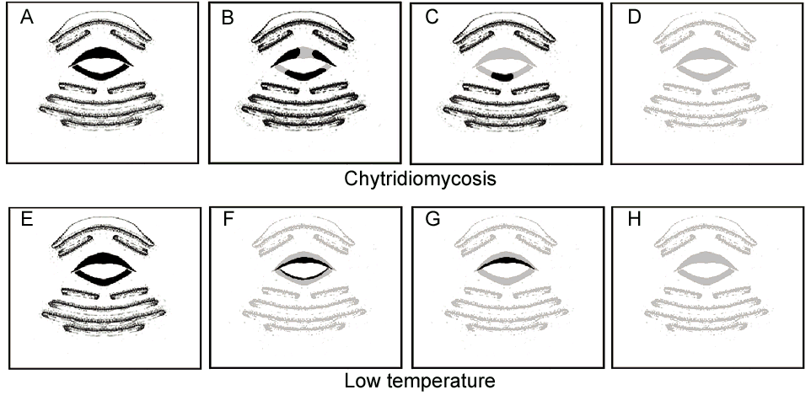
Illustration of larval Rana muscosa mouthparts showing two patterns of pigment loss over time. Upper (anterior) tooth rows, upper and lower (posterior) jaw sheaths, and four lower tooth rows are shown. Black areas indicate pigmentation while gray indicates areas where loss of pigment has occured. A-D represents the pattern of loss associated with chytridiomycosis and E-H represents the pattern of pigment loss associated with an overwintering temperature. Note that R. muscosa tadpoles can have two additional tooth rows with large medial gaps anterior to the upper jaw sheath.

Equipment List for Conducting Surveys

  - Lakes to be sampled list
  - Sampling protocol
  - Handspring + waterproof/transparent case
  - Rechargeable AA and AAA batteries
  - Backup module
  - Otter box
  - Solar battery charger
  - Topographic maps, large scale maps
  - Binder with field guide and datasheets
  - Large and small dip nets
  - Thermometer
  - 20 ml + 60 ml + 125 ml sample bottles
  - Swabs, swab vials
  - Calipers
  - Pesola spring scales (30g and 60 g) + Ziplock bag
  - Hand lens
  - Ethanol
  - Labeling tape
  - Space pen
  - Sharpie (“ethanol-proof”)
  - Mechanical pencil
  - Dry bags for disinfection
  - Quat 128
  - GPS unit + case
  - Dropper
  - Notebook
  - First aid kit
  - Satellite phone + waterproof bag
  - MS-222 + buffer.
  - Mosquito nets.
  - Water filter or iodine tablets.
Natural History Tidbits

Fairy shrimp (3 species in the study area)
Heads of male fairy shrimp showing genus-specific antennae.

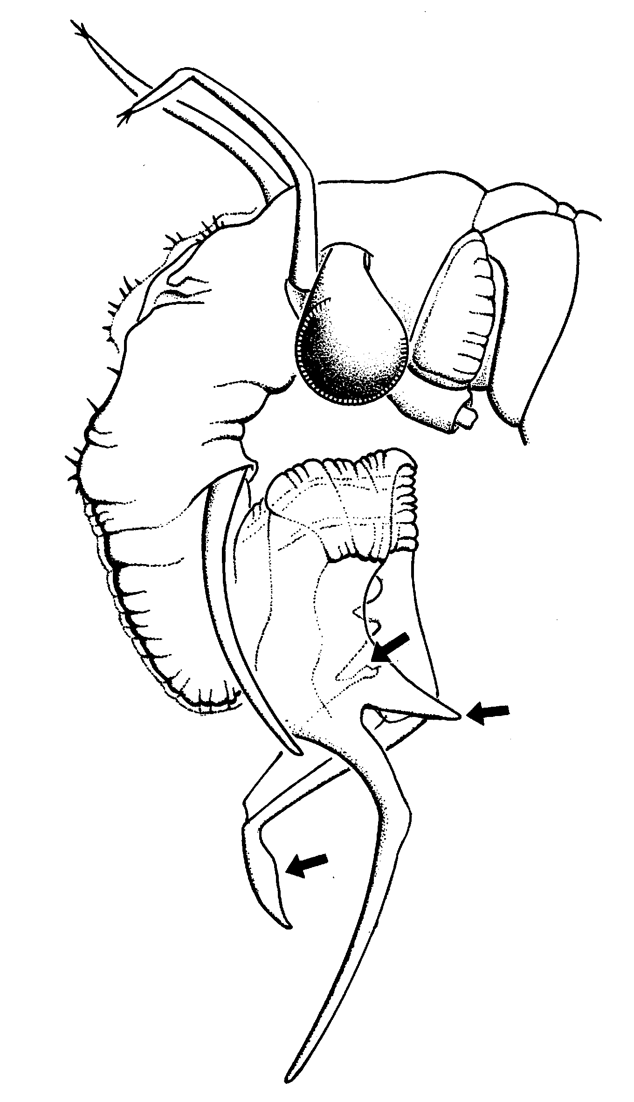
Streptocephalis sealii Branchinecta sp.
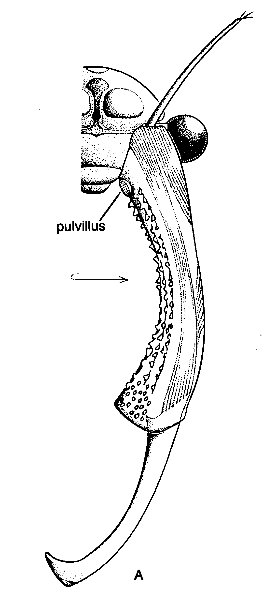

Mayflies (Ephemeroptera: 2 species in the study area)

Adult Larvae
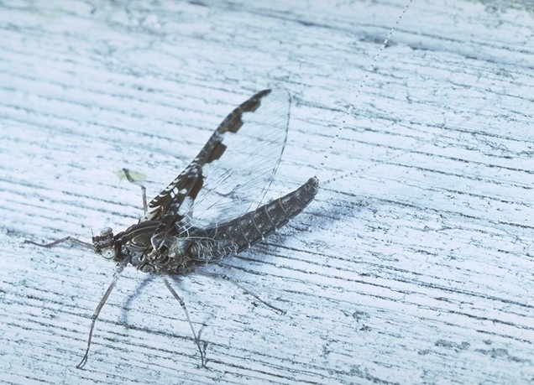
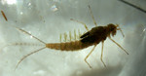
Mayfly adults have vertical upright wings (speckled in Callibaetis, clear in Ameletus) and 2-3 long tail filaments. Adult males (imagos) are needed for species-level identification. Males can be distinguished from females by their very large eyes. Imagos can be distinguished from subimagoes by their clear instead of dusky wings. Emerge in early summer.

Caddisflies (Trichoptera: at least 4 species in the study area)

Adult Larvae
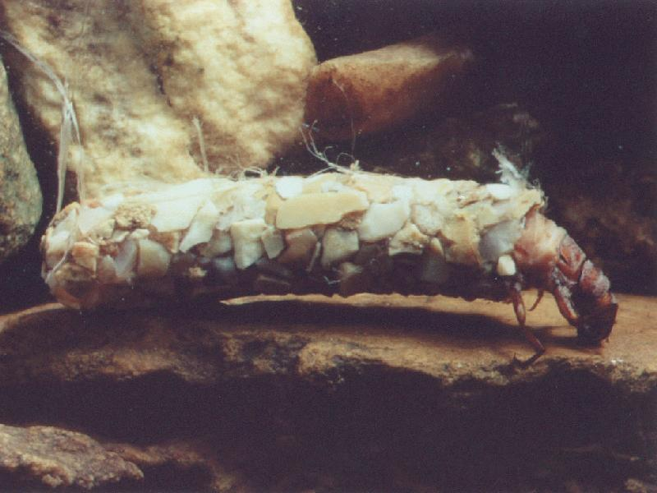
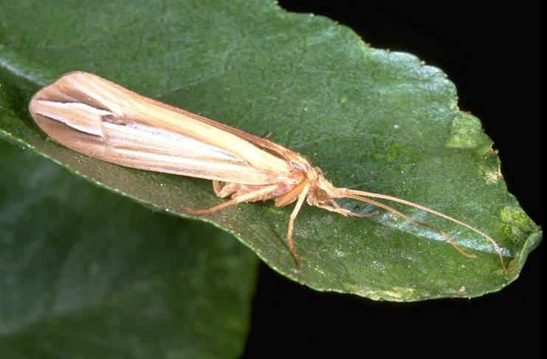
Caddisfly adults can be identified by their beige-to-brown wings held parallel to the body and long antennae. Usually 1-4 cm in length. Emerge in mid-late summer. Most species in the study area have larvae that build cases, but a few are free-living.

Alderflies (Megaloptera: probably only 1 species in the study area)

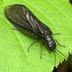
Adult appearance is similar to caddisfly adults, but alder flies are black and lack long antennae.

Predatory Beetles (Dyticidae: 10+ species in the study area)

Adult Larva
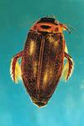
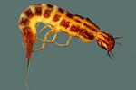

All life stages are aquatic.

Damselflies and Dragonflies (Odonata: at least 5 species in the study area)

Damselfly Dragonfly
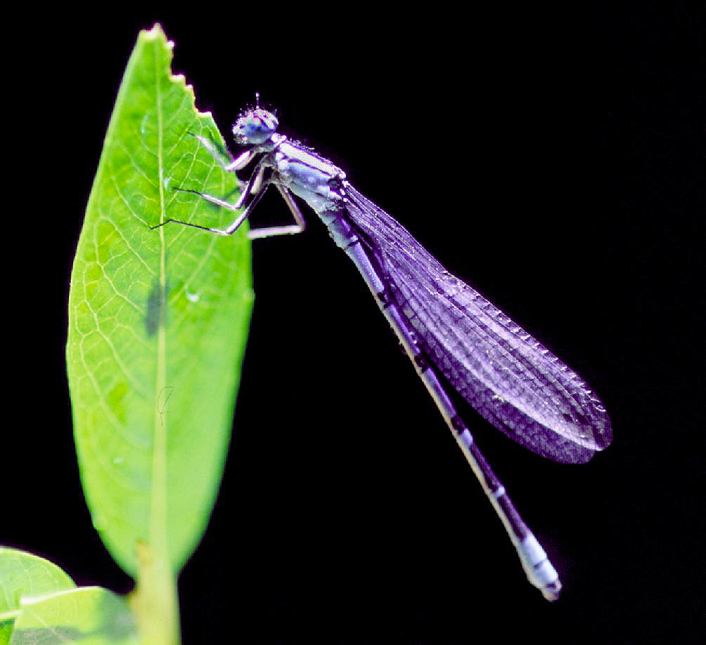
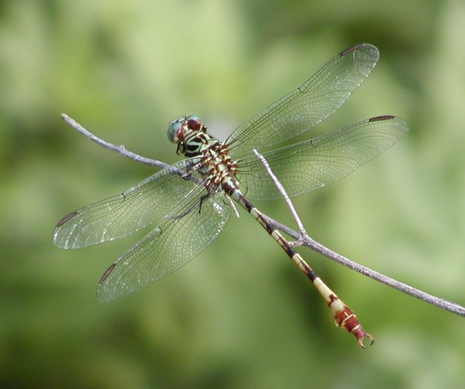
Adult damselflies have very thin abdomens and hold their wings folded together above the body. Dragonflies have thicker abdomens and hold their wings extended and out from body

Corixids and Notonectids (Hemiptera: at least 5 species in the study area)

Corixid (water boatman) Notonectid (backswimmer)
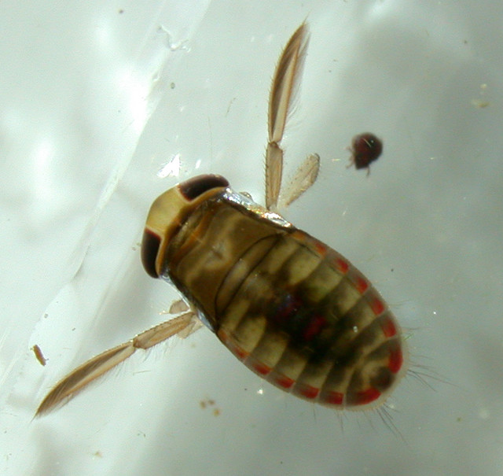
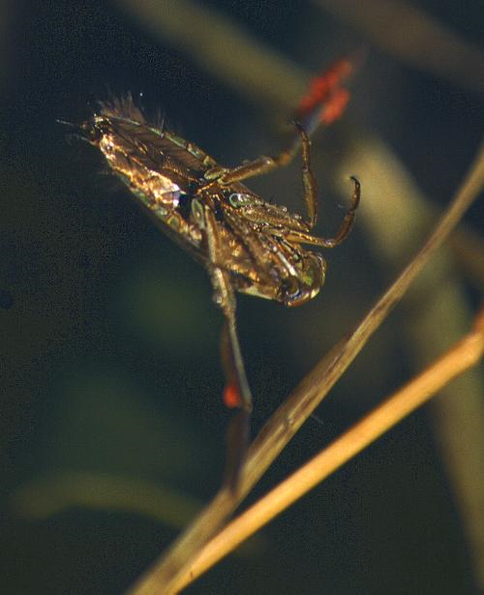
All life stages aquatic.

